Press Release
The following statement issued to the media by the joint platform of CTUs and Independent Sectoral Federations and Associations on 9th February in the press conference held at Press Club of India, New Delhi.
Onward to Nationwide General Strike and mass mobilisations on 12th Feb.2026
Resistance to anti-worker, anti-farmer and anti-national pro-corporate policies of the Central government.
The Joint Platform of Ten Central Trade Unions, and independent Sectoral Federations and Associations had given a call endorsed by the National Convention of Workers held on 9th January, for observing 12th February as Nationwide General Strike and massive mobilisations throughout the country across all sectors, formal/informal, government, public sector, industrial areas, rural and urban India. The Samyukt Kisan Morcha extended full-fledged support for joining the protest and mobilisations on their demands and in support of the demands of trade unions. Similarly, the joint front of Agricultural workers unions is also in the campaign and joining the strike specially focusing on the restoration of MGNREGA.
The wide campaigns have been taken up in almost all the states, in all sectors- government, public and private sector establishments, industrial areas, amongst the workers, farmers and common masses in rural and urban India. The students and youth groups joined in several places for such campaigns. The common citizens have been extending their support to the demands of the strike. The strike notices have been served in most of the sectors/ industries. The preparations are full-fledged.
This strike action is taking place in a very critical situation, when the union government, in order to contain and weaken the trade unions and place the Indian Working-Class Movement disarmed in face of the onslaught of capital, have notified the four labour codes and rules thereafter.
The labour codes were brought without due process of law, no consultations with stake holders, not holding Indian Labour Conference defying international labour standards to which India as the Nation state is signatory. The codes were passed in the Parliament with brute force and in case of three codes even in absence of whole opposition from the Parliament and during Covid 19 period with Disaster Management Act which prevented gatherings. This was specifically done with the idea that no protests will be allowed by the police machinery.
The notified labour codes and the draft Rules are to crush the collective bargaining to take away the right to strike, almost 70 percent factories will be out of labour law coverage, regulation and employers’ obligations to leave workers at the mercy of employers, throw out vast majority of workers from the protection of occupational safety and also from social security, would virtually demolish the existing rights and wage protections through conciliation/adjudication procedures; wage definition itself is proposed for change, trade union act is to be repealed and proposed code is to make unionisation cumbersome/impossible towards arbitrary deregistration and de- recognition, vindictive punitive actions against collective trade union activities and license to employers to violate their statutory obligations at their whims. In totality the Labour Codes are articulately designed by the Govt. to impose conditions of slavery on the workers and their trade unions, to facilitate their corporate masters to continue their loot on the workers, farmers and people in general. The budget speech of the finance minister on 1st February repeatedly talked of taking steps for 'Ease of doing Business'.
The Government has no intention to continue India as a Welfare State. Replacing MGNREGA with VB GRAMG Act is clear indication. The women are not to get dignity of being part of the labour force, decent jobs, they are also being treated as objects to garner votes through various means. The youth is denied job, and in this budget also there is talk of employability and not of employment generation.
The strike action is in a background of a worrisome situation of deteriorating economy, growing unemployment, increased attack on the democratic rights of people, venomous campaigns of polarisation and hatred against the minorities, attack on all democratic institutions and filling them with blind supporters of the ruling party with dubious agenda of obliterating the rights of freedom of association, expression and dissent.
The government continues its agenda of privatisation and sale of all strategic Public Sector Undertakings and Public services such as railway, port and docks, coal mines, oil, steel, defence, roadways, airports, banks, insurance, telecom, postal, atomic energy, electricity generation and supply etc. to the advantage of big corporates of Indian and foreign origin thus endangering indigenous industrial growth and self-reliant economy. The budget 2026-2027 continues this very direction. The announcement of constitution of High-level committee to reform banks is a clear call to privatisation of public sector banks.
Unemployment is alarmingly growing and government is not filling sixty-five lakhs vacant posts, rather retirees being recruited against jobs as contract workers. The government is continuously pursuing the policies against farmers under different guise since after the agitating farmers forced the government to withdraw three agricultural laws which were brought to corporatise the agriculture and grab land to the advantage of the chosen few corporate houses. Now the government has come out with Seed Bill which will give businesses to Foreign infamous Corporates dealing with seeds and our agricultural universities and the farming community will be under severe attack.
The budgeted allocations for 2026-2027 become meaningless when one looks at similar exercise conducted for 2024-25 and 2025-26: funds allocated for crucial sectors like education, health, social welfare were not utilised at all (Source: Economic Survey for respective years). The commercialisation of education and health are severe jolt to the people as they cannot afford the cost. The budget allocations for education, health and social welfare together is only 6% whereas the defence and transport get 22%. It is known that government is privatising defence and infrastructure sectors aggressively in favour of its chosen corporate friends.
The Central Government instead of responding to legitimate demands of the people, has increased its assault on all sections in the advantage of its cronies in the Corporate World. Rather the government is busy giving concessions and leverage to the foreign companies to the disadvantage of small businesses and trade, MSMEs which provide major chunk of employment.
The latest deal with USA with 18 percent tariff on Indian goods whereas zero tariff on import of American goods to India is another blow to our farmers, animal husbandry sector and MSMEs. The statements of Ministers are contradictory to each other whereas US officials are telling clearly that USA farmers are going to get strong foothold in India for their produce. Our government has been surrendering India’s Interest in the foreign trade.
The Government has come out with Draft Labour Policy-Shram Shakti Niti-2025 once again without talking to Stakeholders, the policy brought to push for implementation of the four labour codes and with clear direction of decimating the role of trade unions, the work/labour termed as dharma and not a right, changing/abdicating role of the Govt. from regulator and compliance/enforcement of laws to a vague, deceptive and undefined role of so called employment facilitator, undermining collective bargaining.
The state/district/ sectoral conventions held, jatha programmes on tractors and other vehicles held, padayatras with leaflet distributions conducted. The campaigns were conducted on all the demands of workers and farmers and the sector specific demands.
The immediate demands of the strike were also focussed as:
- Scrap of Four labour codes and Rules.
- Withdraw the Draft Seed Bill and Electricity Amendment Bill
- Withdraw the “Sustainable Harnessing and Advancement of Nuclear Energy for Transforming India (SHANTI) Act”, which will allow private and foreign players to enter highly risky and hazardous nuclear power production with a motive of profit;
- ·* Restore MGNREGA and scrap the Viksit Bharat – Guarantee for Rozgar and Ajeevika Mission (Gramin) Act, 2025.
- Withdraw decision of 100% FDI in insurance companies.
- Withdraw the Viksit Bharat Shiksha Adhishthan Bill, 2025
- Fill vacant government, public sector posts; regularise Anganwadi, ASHA, MDM workers to make them government employees, make NHM doctors and nurses permanent.
We had welcomed the protest action organised by the INDIA BLOC Parties in the premises of Parliament opposing the Labour Codes. We call upon them and various other sections of the people, especially the youth and students, to come forward in support and solidarity with this Strike to save the basic rights of the working people and protect the democratic – secular fabric of the country.
Onward to Nationwide General Strike and Mass Mobilisations on 12th February 2026
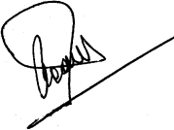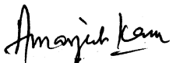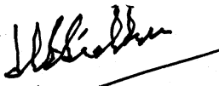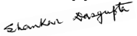
INTUC AITUC HMS CITU AIUTUC
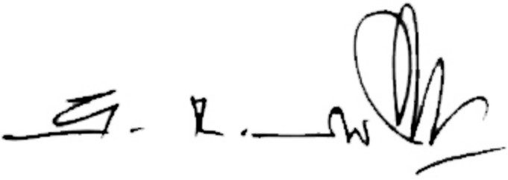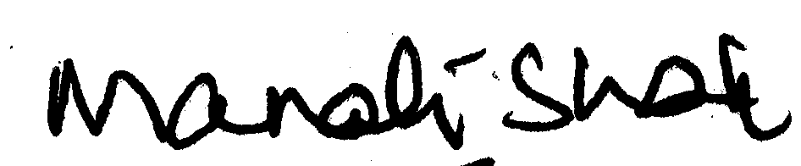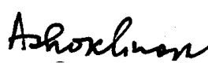
TUCC SEWA AICCTU LPF UTUC
The joint Platform of the Central Trade Unions and Sectoral Federations/Associations

